***Wroclaw city centre walking tour***

**The most important and most interesting monuments in Wrocław should be put on your list as a must to see. You can visit them in two days during a leisurely walk around the city. Some places visited during the day should be seen again at night under lamp light or moon light! So come with us for a stroll with The Visitor which will ensure you won’t miss the most important places in Wrocław which are in our guide. Put on comfortable shoes, take your camera and some change for tickets and of course take The Visitor - Wrocław awaits you!**

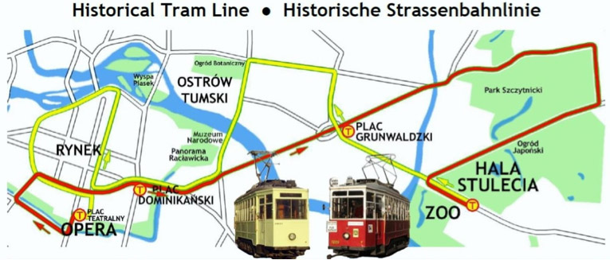

Our guided tour starts from the best orientation point in the city which is the main train station. Go out of the main hall, turn left onto Piłsudskiego Street and after 500 m turn right into Świdnicka Street - the most representative and one of the oldest streets in Wrocław. A further 500 mand you will see, on your left, the Opera.

Opera Wrocławska, Świdnicka 35 St., tel. +48 71 370 88 80. The theatre was built between 1837-41 by Carl Langhans (creator of the Brandenburg Gate in Berlin). The Classical style construction was burnt down twice and rebuilt several times. Until 1944 the theatre was one of the most prestigious stages in Germany. The first post war presentation was ’Halka’ by S. Moniuszko and was performed on 8 September 1945. Since then around 260 premieres have taken place here. The Opera is widely known for its splendid open air operatic presentations and its super productions presented in the Ludowa Hall (see our calendar of events). Unfortunately the building is under renovation at the moment.

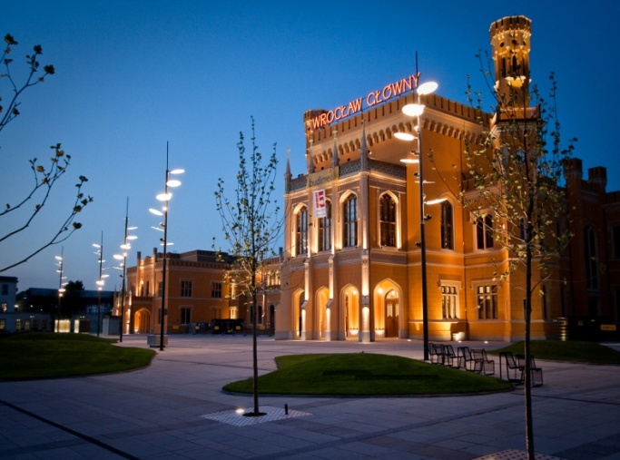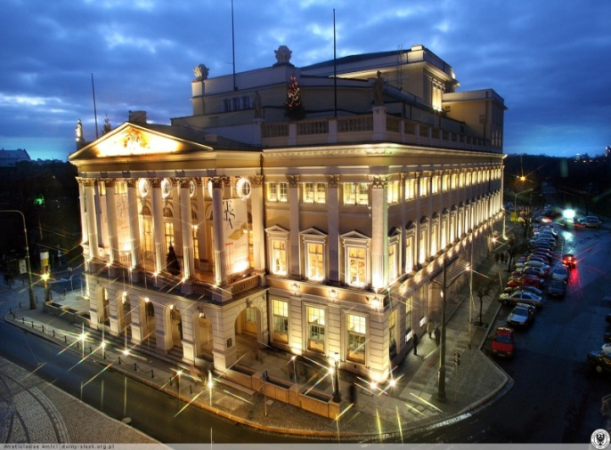

The Market Square is 212 x 173 m (3,7 ha) and was laid out in the XIII Century. After the houses were renovated, security increased (camera surveillance system) and restaurants opened the Market became the most popular spot in Wrocław and is now well known in Europe. The Market is surrounded by houses of historical importance, many of them reconstructed after the siege of Wrocław in 1945. In 1985 the sandstone copy of the 1492 Pillory was erected in front of the City Hall. Until the XVIII century thieves and other criminals were publicly punished here (could do with some of that today perhaps...). On top of the Pillory stands the figure of Ronald, the medieval symbol of justice. On the opposite side of the Market is the modern glass. Fontana which looks interesting in daylight and more interesting at night when the light mixes with the water and the glass. Not far from here is the monument to writer Aleksander Fredro who moved here from Lvov in 1956 to take the place of amonument to Emperor Wilhelm.

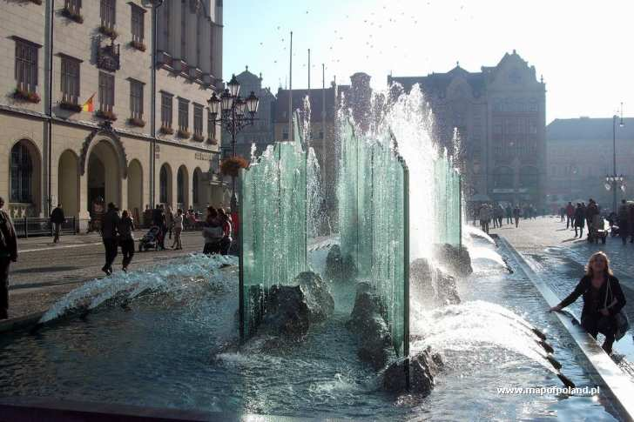 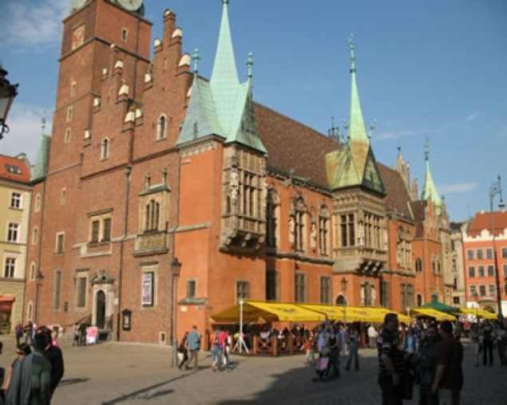

The most outstanding monument in the Market is the City Hall. Construction was started in 1290 and continued, rebuilding, additions and extensions, over the centuries. The present Gothic and Renaissance construction with its ornamented facade is quite breathtaking. On the top of the 66 meter tower is the city crest from 1536 and the astronomic clock from 1580. An interesting Wroclaw City Museum is located in the City Hall (tel. +48 71 347 16 93).

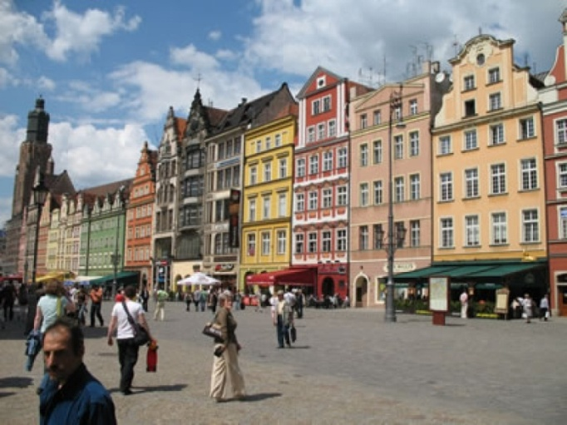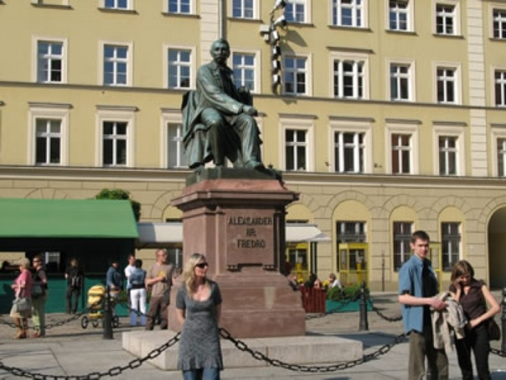

The Plac Solny (the Salt Square) is joined to the Market Square. It is smaller, 100 x 90 m, and was originally used as a trading place, most likely trading with the then precious commodity, salt. If a name was to be given to the square today it would certainly be called Flower Square. You can buy a bouquet of roses in a number of florists until late evening even deep into the night should you feel romantic enough! Note some interesting buildings here. No 16 is the Classical style home of the Old Stock Exchange in Wrocław, constructed by C. Langhans (1822 -24); No 2 is called the ’Little Negro house’, and No 4, is the XVII

Century Oppenheim family residence.

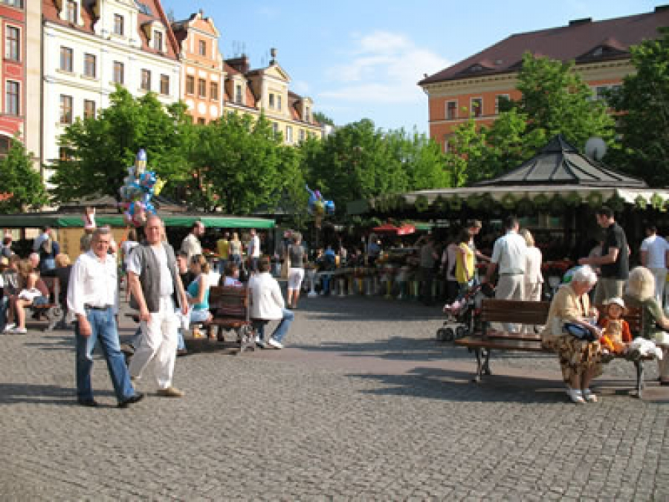

The other corner of the Market is enclosed by two charming arched houses known by locals as little John and little Mary house. Look at the arch and you will see the Latin inscription, ’Death is the gate to life’. The St. Elisabeth church (mid XIV, beginning of XV century) was the place of worship for rich merchants. Inside you will find a number of sacral monuments (theWolffmonument 1722, Pfintzing epitaph XVI c., Saurmann epitaph XVI c.). If you are feeling strong try climbing the 91 meter church belfry! While plodding up, with a rest somewhere in the middle, remember the original tower was 128 m. high, the tallest in the city. In 1529, much to the satisfaction of the Catholic population of the town, the Protestant church tower steeple (the church was Protestant in those days) fell down in a storm. The Catholics said it was to punish the sinning Protestants - the Protestants said it was a miracle nobody was killed when it happened. Entrance to the tower observation deck open daily after the notification of the sacristy. And there is a very good view from the top.

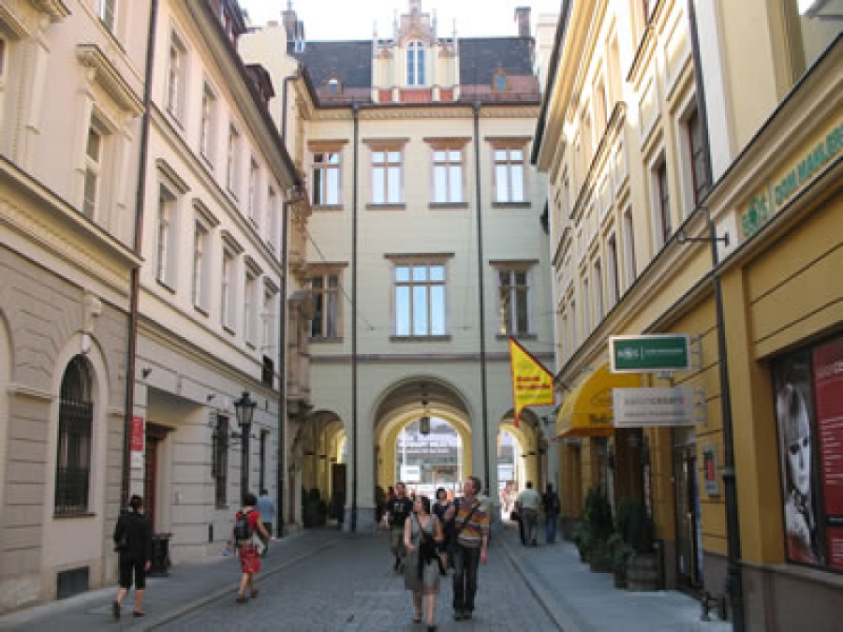

Behind the church, between Odrzańska and Kiełbaśnicza street are the Old Shambles. Today this is a very pleasant area, full of galleries but historically it was the part of the city where butchers had their shops. The square has a picturesque monument of the animals that were butchered, a popular spot for photos, children and adults alike. *After walking around the Market leave it by Kuźnicza street (the* *prolongation of Świdnicka street, the one we came to the Market* *Place with, remember?). About 400 m further we arrive at* *University Square and the Church of the Blessed Name of Jesus.*

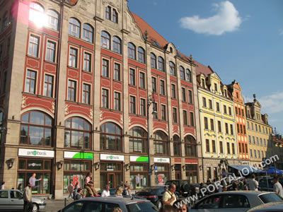 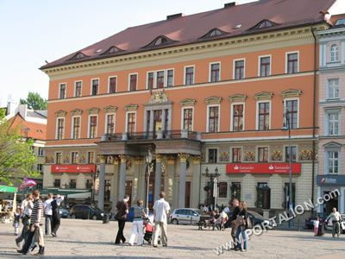

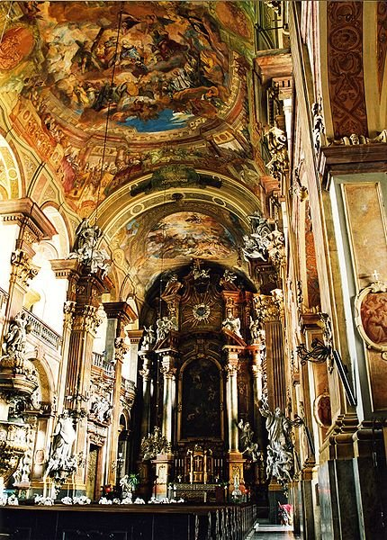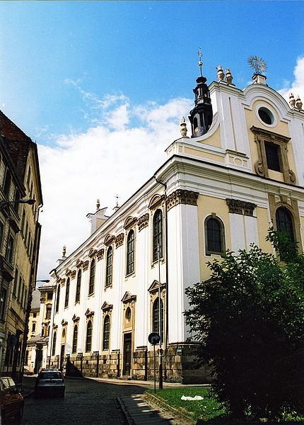

The church of The Blessed Name of Jesus is probably the most beautiful Baroque building in the city. Built by the Jesuits in 1689 -1700 it has spectacular interiors with sculptures and wall and ceiling frescos by K. Tausch and F. Mangoldt. Take some time to see the frescoes at the top of the J. Rotmayer representation of the Adoration of the Name of Jesus (1706).

Construction of Wrocław University was begun by the Jesuits in 1728 and lasted till 1741. Inside you can visit the beautiful Baroque Leopold Aula style room and the ground floor room of F. Longchamps and Oratorium Marianum. Construction of Wrocław University was begun by the Jesuits in 1728 and lasted till 1741. Inside you can visit the beautiful Baroque Leopold Aula style room and the ground floor room of F. Longchamps and Oratorium Marianum.

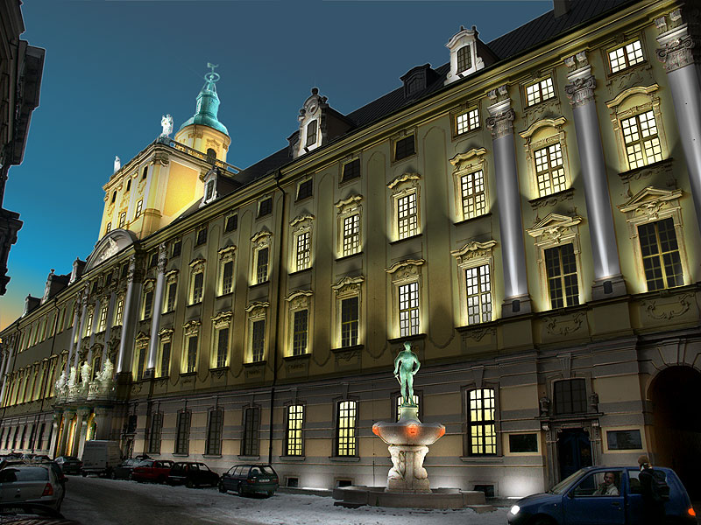

You can also visit the Mathematics Tower with an entrance to the belfry and a panoramic view. *Leaving the university go through the Emperor's Gate passage* *to Grodzka street and turn right down to the Piaskowy Bridge* *(the Sand Bridge) c.a. 800 m, and on to the Piaskowa Island. Then enter the boulevard on the right (06.00-23.00).*

Piasek Island (The Sand Island) is connected to the mainland by the Tumski, Młyński and Piaskowy bridges. The Augustan convent church standing here form 1149 is now the largest library in Poland. In 1998 the pedestrian boulevard which was built here was named the Włostowica Boulevard. The picturesque location makes it one of the favorite walking areas

in town, and a neighborhood for artists painting views of Ostrów Tumski.

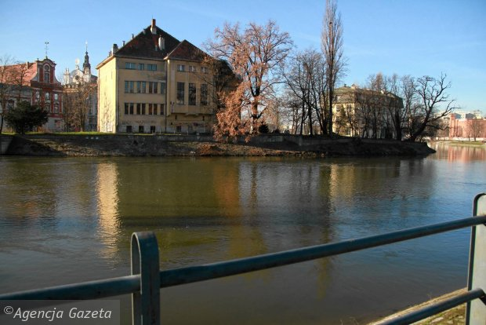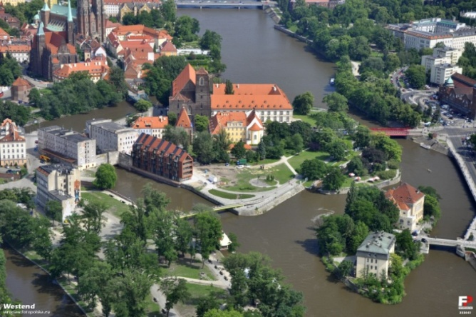

The monument of Wrocław’s Metropolit Cardinal Bolesław Kominek was unveiled at the church square (toward Tumski Bridge) on 2nd of December 2005. This special event was to

commemorate the sending of the letter from the Polish Bishops to the Bishops of Germany on 18th November 1965. This letter, called the Manifesto for Reconciliation, started the political repressions within the Polish Catholic Church by the communist government who considered this act by the Bishops as a betrayal. A sentence from the letter, written also on the monument, is a base for reconciliation between the Polish and German nations: ’We forgive and ask to be forgiven’ has a special meaning in this historically unique city of Wrocław.

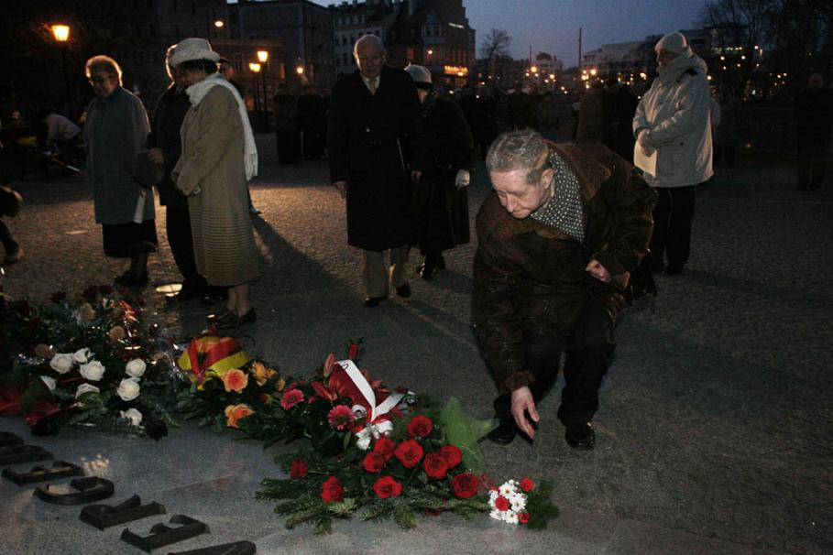 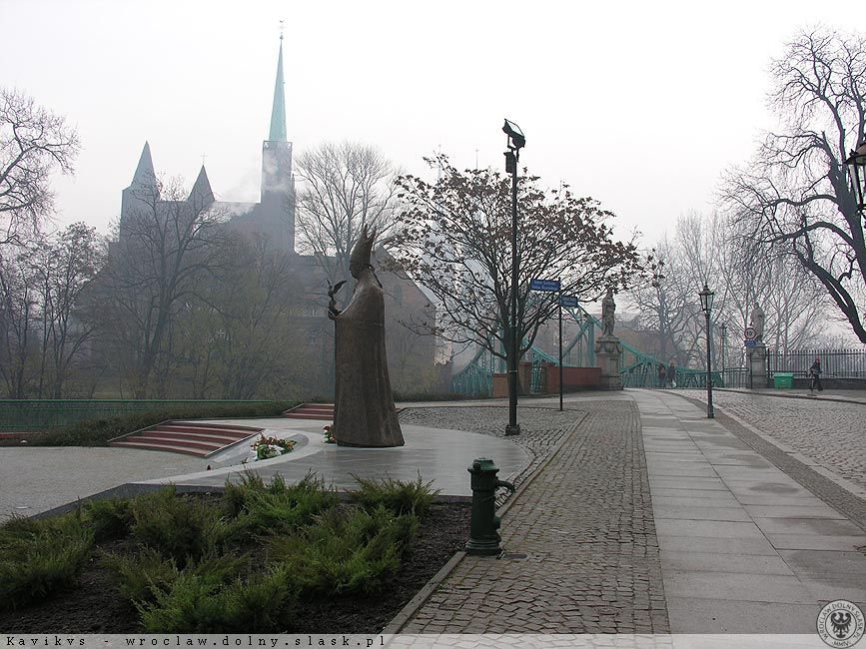

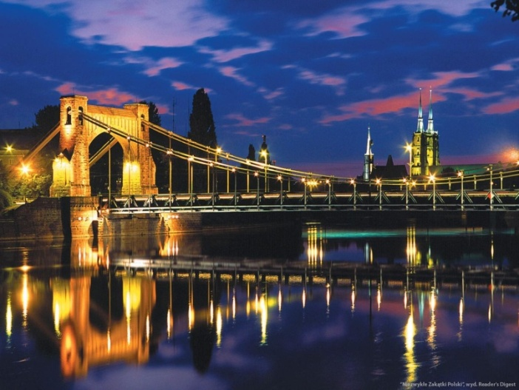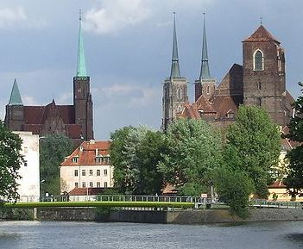

The Ostrów Tumski was a separate island until 1824 then part of the river was covered over. In 1504-1810 this area was exclusively church territory and a sanctuary for those pursued by secular law. The sacral and municipal buildings were destroyed several times by fires, flood or during the siege of Wrocław in 1945. The people of Poland remember the heroic citizens of Wroclaw and their struggle with the Great Flood of 1997 when they successfully defended Ostrów against the flooding of the area by the Odra river.

A little further along the street you will see the monument to Jan Nepomucen. It was made in 1731 by J. Urbanski to the design of C. Tausch. After admiring this monument enter the church behind it. The church of the Holy Cross was founded by Henric Probus in 1288 and is the first of its kind in Wrocław, a church on two levels. The lower church is under the patronage of St. Bartolomy. In the left nave of the upper church there is a copy of the Turin Shroud.

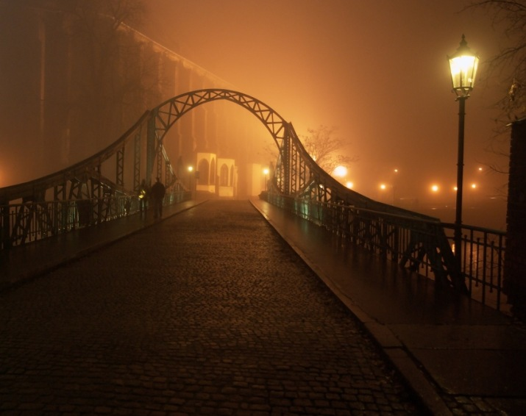 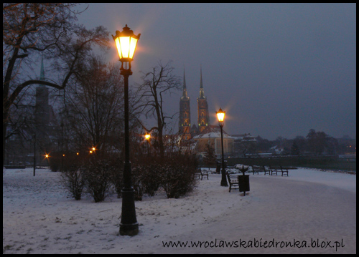

At the end of our city tour walk round the cathedral and try not to miss the St. Idzi church, small but of great importance as it is the oldest church in Wrocław. It is in Roman-Gothic style and was founded in the XII century. Here we say goodbye for now. Take a stroll across Ostrów Tumski on the way back to your hotel and have a rest, or a beer, or a cup of tea. But remember to return at night to see a different face, lit by the lights of the city. They call it here, The Magic of Wrocław!

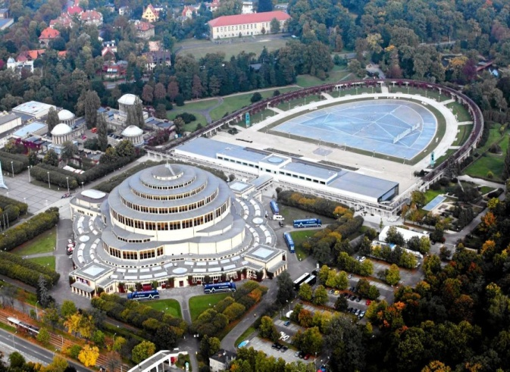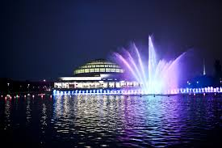

You can’t say you have seen Wrocław without a visit to its ZOO, the most famous in Poland. You also have to visit Szczytnicki Park and the Centennial Hall and the Japanese garden.

The first park projects, the initiative of FL von Hohenlohe - Ingelfingen, were constructed at the end of XVIII century. The development of an actual park is from the end of XIX c., when the ideas of royal gardener P. Lenne and botanist H. Göppert were implemented. In 1913 when the 100th anniversary of the defeat of Napoleon at Lipsk in 1813 was celebrated, the city municipal council organised an exhibition called ’the century exhibition’ and they built the Centennial Hall and started the splendid pergola around the pond. In 1948 an exhibition, ’New Polish Lands’, was opened in the park and the 106 m high, S. Hempl, spire was built. Szczytnicki Park is the oldest and largest park in the city. Apart from the monuments there is the rich flora to admire not forgetting the 200 year old oaks in Oak Alley, the 300 year old oak of Jan Stanka or 100 year old beeches.

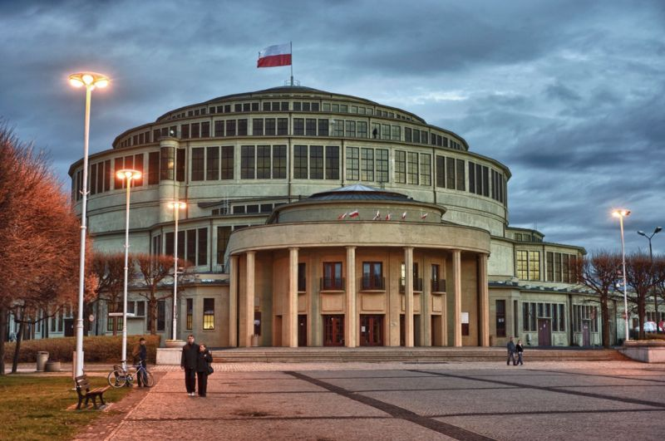 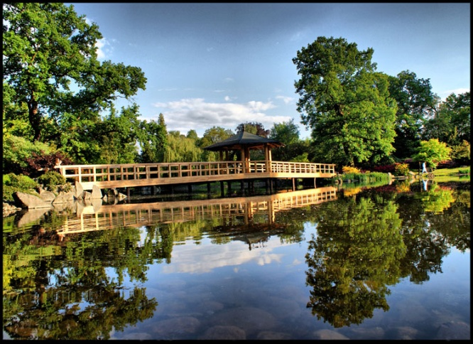

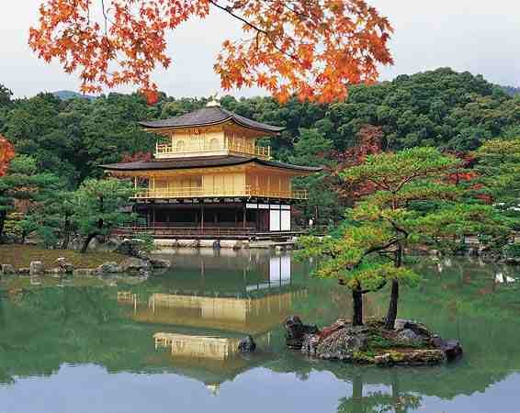 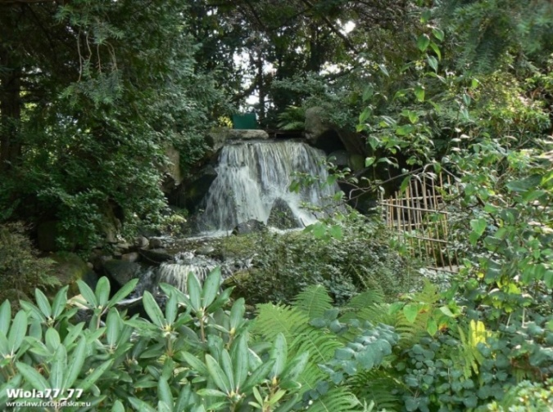



Situated near the Centennial Hall is the largest in Poland and one of the most spectacular fountains in Europe, which offers a multimedia show created by fountains, lights, lasers and music. The fountain is open during the spring and summer season (from May to October) between 10.00 and 22.00. The show lasts from 3.5 to 18 minutes and begins every hour. There are special shows at weekends in the evening. These fountain son et lumiere shows are free. The fountain is located in the middle of the historical Pergola – a 600-foot boardwalk in the shape of a semi-ellipse, surrounded by 750 pillars. The boardwalk is covered by a wooden openwork structure covered with vines leaves. It was built in the early twentieth century and is still a favourite place for citizens and tourists to take walks.

The Japanese Garden was established as part of the Garden exhibition in 1913 by count von Hochenberg from Iłowa and Mankichi Arai from Tokyo. When the exhibition closed, the pathways, pond, streams, and minimountains remained along with the exotic flora. In the 70’s a copy of a Japanese temple from Kyoto was built over the pond and a waterfall and bridge were added

*Return to the street where you left the tram, cross over, use the overhead bridge and on the right you will find the ZOO entrance.*

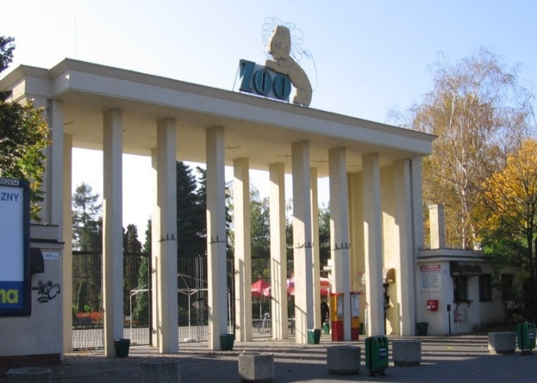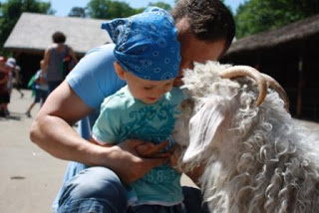

The Wrocław Zoological Garden was opened on 10 July 1865. It has an aviary, an elephant and monkey house and the Floral House from the first days of the gardens. Times were difficult between the wars and the zoo was closed from 1921 to 1927. At the end of WWII the animals had all been killed or eaten and the buildings destroyed. The University of Wrocław came up with the idea of opening a zoo again and in July 1948 the ZOO was opened to the public. Now there are about 6800 animals representing around 600 species. The special attraction of the ZOO is the African Kotiki feeding demonstrations. The new Indian rhinoceros pavilion, the historical terrarium and modernized monkey house are also worth a visit. The ZOO became famous in seventies with the TV programme, ’With a camera among animals’, directed from the ZOO by Hanna and Antoni Gucwiński. The program ran for nearly 32 years and at its height of popularity was followed by 9 million viewers! It was the only national TV program from Wrocław at that time.